
BIRKERØD GYMNASIUM,
HF, IB & KOSTSKOLE

Test 1 P1
IB DIPLOMA PROGRAMME

Mathematics Standard Level SL
Test on Straight Lines, Surds, Data and Sampling and Statistics

October 2019
NO GDC
35 minutes

Instructions to candidates:
- Write down your name in the space provided.
- Do not open this examination paper until instructed to do so.
- A graphic display calculator is not allowed for this test
- Answer all the questions
- Write your answers in the spaces provided.
- You are advised to show all working, where possible. Where an answer is wrong, some marks may be given for correct method, provided this is shown by written working.
- Unless otherwise stated in the question, all numerical answers must be given exactly

Points:_______________/ Grade:

Please circle your chosen Mathematical Subject:

Analysis and Approaches (AA) or Applications and Interpretation (AI)

Name:______________________________________________________________________________________

Teacher: (AA, ARC or ANU) ______________________________________________________________
- The heights in cm of the members of 4 volleyball teams A, B, C and D were taken and represented in the frequency histograms given below.

The mean and standard deviation σ of each team are shown in the following table.
 | I | II | III | IV
 | 194 | 189 | 188 | 195
σ | 6.50 | 4.91 | 3.90 | 3.74

Match each pair of and σ (I, II, III, or IV) to the correct team (A, B, C or D).
and σ | Team
I
II
III
IV
(Total 6 marks)

- The following box-and-whisker plot shows the number of text messages sent by students in a school on a particular day.

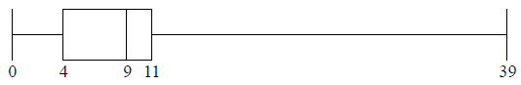

(a) Find the value of the interquartile range. [2 marks]
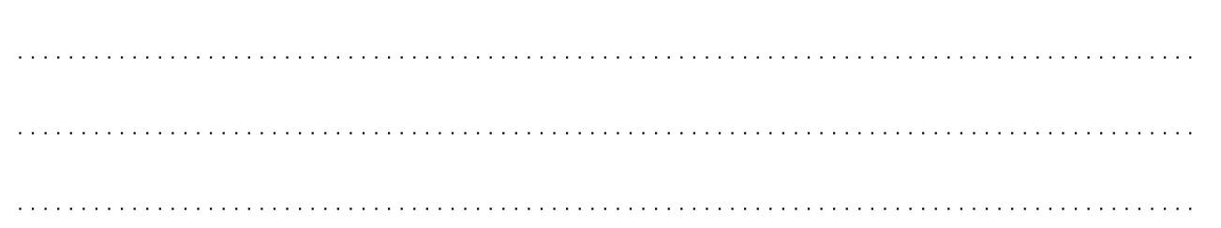

(b) One student sent k text messages, where k > 11 . Given that k is an outlier, find the least value of k.
[4 marks]

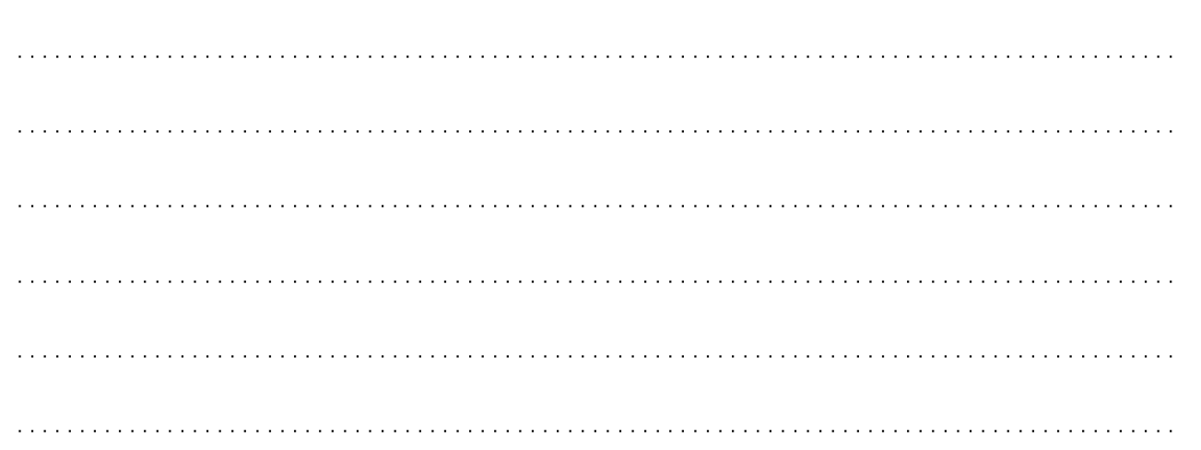

- There are 10 items in a data set. The sum of the items is 60.

(a) Find the mean. [2 marks]

The variance of this data set is 3. Each value in the set is multiplied by 4.

(b) (i) Find the value of the new mean. [2 marks]

(ii) Find the value of the new variance. [2 marks]

- (a) Show that $\left(\sqrt{10}+1\right)\left(\sqrt{10}-4\right)=6-3\sqrt{10}$. [2 marks]

(b) Simplify fully $(\sqrt{10}+4)(\sqrt{10}-4)$. [2 marks]

(c) Hence, rationalise the denominator and simplify $\frac{(\sqrt{10}+1)}{(\sqrt{10}+4)}$ and writing it in the form $a+b\sqrt{10}$ , where $a, b∈Q$.
[4 marks]
- The following frequency distribution of marks has mean 4.5.

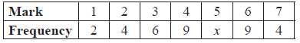
Find the value of x. [4 marks]

- The graph below shows the graph of a straight line.

(a) Write down the equation of the straight line in the form $y=mx+c$. [2 marks]
(b) On the same graph, draw the line with equation $3x-2y-4=0$. [2 marks]

(c) Using your graphs, or otherwise, solve the equation $\frac{3}{2}x-2=-\frac{1}{2}x+6$. [2 marks]

